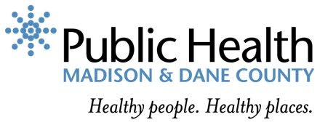

Performance Management & Quality Improvement Plan

Created 2018

Table of Contents

Purpose, Vision and Guiding Principles 4
Purpose 4
Vision 4
Guiding Principles 5
Key Terms and Definitions 5
Organizational Structure and Governance 7
Role of PHMDC Employees 7
X-Team 7
Managers 7
Performance Management Implementation Team 8
Performance and Quality Improvement (PQI) Committee 8
All-Staff 8
Performance and Quality Improvement (PQI) Committee 9
Performance Management Activities 9
Performance Management System Model and Framework 9
Performance Objectives, Measures, Targets, and Actions 13
Strategic Pan Monitoring and Review 14
Quality Improvement 14
Training and Support 14
Training Topics and Approach 15
Communication 15
Communication to Key Groups 16
Executive Team (X-Team) and Managers 16
All-Staff 16
Board of Health 16
Public 16
Public Health Community of Practice 16
Links to Other A-Plans 17
Community Health Assessment & Community Health Improvement Plan 17
Strategic Plan 17
Workforce Development Plan 17
Monitoring and Evaluation 18
References and Resources 18
Models and Inspiration for Plan Form and Content 18
Appendix A: Glossary of Key Terms 18
Appendix B: Performance Management Activities Documents 19

Purpose, Vision and Guiding Principles

Purpose
Public Health Madison & Dane County’s (PHMDC) mission is to work with the community to enhance, protect, and promote the health of the environment and well-being of all people. Achieving this mission requires the adoption of strategies centered around continuous improvement, as well as assessment of progress towards agency objectives and identification of ways to improve our processes, programs, and services to meet the needs of agency staff and the greater Dane County community.

The purpose of the Performance Management and Quality Improvement (PM/QI) Plan is to provide a framework for implementing performance management and quality improvement activities within Public Health Madison & Dane County. The PM/QI Plan will provide guidance for the creation of a Performance and Quality Improvement Committee that will lead agency-wide efforts to:

- Establish and utilize PHMDC’s Performance Management system InsightVision to assure data-informed decision-making
- Implement a systemic quality improvement approach
- Embed these practices in the everyday work of all staff

Vision
PHMDC is committed to developing a culture of quality throughout the agency. Developing this culture requires a shift in current agency operations such that performance management and quality improvement are embedded in our everyday work and long-term strategic planning.

Fundamental to this shift includes:

- Assuring leadership commitment to the adoption of a culture of quality
- Empowering staff to utilize performance management and quality improvement tools to guide their own work and work within their programs
- Building a performance management and quality improvement infrastructure to enable tracking, monitoring, and utilization of performance management data.
- Encouraging cross-divisional collaboration to ensure agency-wide development of shared values and standardized processes
- Continuously improving processes to improve quality of services and increase customer satisfaction

Guiding Principles
The PM/QI Plan is guided by the following principles:

- PHMDC is committed to using data to assess how well we are meeting agency objectives and to make changes when necessary. Performance management and quality improvement will support agency success by assuring data-informed practice as we work towards healthy people and healthy places.
- PHMDC recognizes that there is always room for improvement. When an objective is not met, this is an opportunity to reassess and improve agency activities.
- Health and Racial Equity (HRE) must be integrated in performance management and quality improvement as we strive to be an anti-racist agency.

Key Terms and Definitions

Performance management: The practice of using data to guide decision-making processes, identify trends over time, and inform necessary changes to advance PHMDC’s effectiveness in improving the public’s health. Core components of performance management include:

- Performance Standards
  - Identifying the outcomes (or objectives) that you are hoping to accomplish
- Performance Measurement
  - Defining measures that help determine if you are accomplishing the objective(s) or not
  - Setting targets that help determine the rate of progress
  - Determining action steps to take to move the measure
  - Collecting data
- Quality Improvement
  - Using results of performance measurement to identify outcomes (or objectives) that are not being met
  - Using quality improvement methodology and tools to address gaps and make changes
- Data analysis and Reporting
  - Analyzing and interpreting data
  - Reporting on a regular cycle

Objective: A long-term, systemic change the organization or program is looking to accomplish. Objectives can be Outcome level (Major Changes reflected in the community) or Strategic level (Supporting changes for achieving the Outcome Objectives). For example:

Outcome Objective - “Reduce the number of people who die from diabetes”
Strategic Objective- “Increase the availability of diabetes counselors in each community”

Measure: An indicator of progress toward or away from an objective. For example:
- An outcome measure might be: “Number of people living at a healthy body weight”
- A process measure might be: “Number of people attending farmer’s market within the city limits”

Target: A way to show milestones and the rate of progress. For example:
- “Reduce the rate of diabetes from 8.0 per 1,000 to 7.2 per 1,000”

Action: The activity we are doing to move the measure. For example:
- “Create a directory of community partners and the services they provide”

Performance Management System: A fully functioning performance management system that is completely integrated into health department daily practice at all levels includes: 1) setting organizational objectives across all levels of the department, 2) identifying indicators to measure progress toward achieving objectives on a regular basis, 3) identifying responsibility for monitoring progress and reporting, and 4) identifying areas where achieving objectives requires focused quality improvement processes.

Quality Improvement (QI): An integrative process that links knowledge, structures, processes, and outcomes to enhance quality throughout an organization. The intent is to improve the level of performance of key processes and outcomes within the organization.

PDSA: Plan-Do-Study-Act: Also called Plan-Do-Check-Act (PDCA). An iterative, four-stage problem-solving model used for improving a process or carrying out change.

Strategic Plan: A plan that sets forth what an organization plans to achieve, how well it will achieve it, and how it will know if it has achieved it. The SP provides a guide for making decisions on allocating resources and on taking action to pursue strategies and priorities.

Organizational Structure and Governance
All staff at PHMDC play a role in performance management and quality improvement efforts. Specific roles and responsibilities are listed below.

Role of PHMDC Employees

Executive Team (X-Team)
- Nominate and select PQI Committee members
- Allocate resources for PM and QI, assuring that staff has access to resources needed to conduct performance measurement, QI projects, and training activities
- Report on PM and QI activities to the Board of Health and other entities as appropriate
- Actively learn about performance management, quality improvement, and change management including participation in external learning opportunities

Managers
      - Nominate PQI Committee members
      - Promote a culture of quality within their Program(s) and Division
      - Facilitate the implementation of PM and QI activities at the program level
      - Oversee setting of program-level objectives, measures, targets, and actions
      - Approve all submitted program-level performance measures
      - Ensure regular monitoring of program performance measures by using InsightVision platform at regular meetings
      - Support program staff in their work with PM and QI activities
      - Foster a culture of learning and QI within respective programs
      - Actively learn about performance management, quality improvement, and change management

Performance Management Implementation Team
      - Coordinate all divisional Performance and Quality operations
      - Coordinate monitoring and review of the Strategic Plan & PM/QI plan
      - Coordinate performance management and quality improvement training for both the PQI Committee and general staff
      - Organize and maintain Performance and Quality folder on the common S-drive
      - Record and distribute meeting minutes
      - Ensure Strategic plan, PM/QI plan and all PQI Committee documentation meet PHAB Accreditation requirements
      - Actively learn about performance management, quality improvement, and change management including participation in external learning opportunities

Performance and Quality Improvement (PQI) Committee
- Attend regular meetings and complete assigned tasks
- Actively learn about PM and QI
- Prioritize and select QI projects
- Advocate for QI and encourage a culture of learning and QI among staff
- Monitor and evaluate QI projects
- Review, monitor, and regularly report on program-level performance measures
- Provide and/or source technical assistance for QI projects
- Be familiar with the PM/QI plan and Strategic Plan
- Participate in evaluation of the Strategic and PM/QI plans
- Recognize individuals and teams and celebrate milestones and successes
- Make recommendations for improvement projects based on PM results

All-Staff
      - Develop an understanding of basic PM and QI principles and tools through participation in PM and QI training
      - Identify areas for improvement and suggest improvement actions
      - Report training needs to the PQI Committee
      - Contribute to the development, monitoring, and evaluation of the Performance Management system

Performance and Quality Improvement (PQI) Committee
The PQI Committee serves as an oversight committee for Performance Management and Quality Improvement activities implemented across the agency. Committee members will champion PM/QI efforts throughout the agency, and will develop expertise in these areas in order to monitor and evaluate PM/QI proposals and provide technical assistance to programs, division, and the agency as PM/QI is integrated into all activities.

The committee will be a cross-divisional group of staff representing all leadership levels of the agency (e.g., Executive Team, Managers, and Staff). Selection criteria and composition for the committee will be determined in collaboration with the Quality Improvement A-Plan team by December 31, 2018.

Performance management activities

Performance Management System Model and Framework
PHMDC has adopted the updated Turning Point Public Health Performance Management System as the framework for its performance management system (see Figure 1) in combination with the Balanced Scorecard approach (see Figure 2). PHMDC is finalizing the PHMDC specific model (see Figure 3).

The Turning Point Public Health Performance Management System framework outlines the core components of a successful performance management system: Performance Standards, Performance Measurement, Reporting Progress, and Quality Improvement.

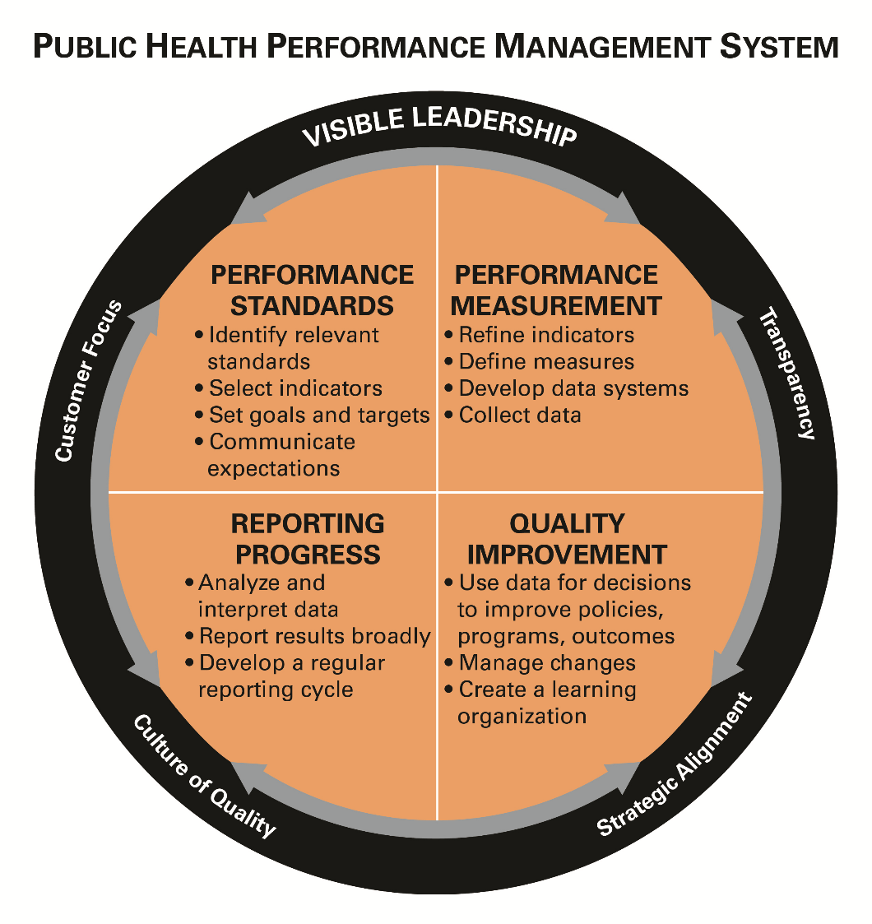

Figure 1. Turning Point Performance Management System Framework as updated by the Public Health Foundation (Public Health Foundation, 2015).
The Original Balanced Scorecard Approach was developed as a management tool, originally applied to businesses in the private sector, developed by Kaplan and Norton in 1992. Their tool broadened the traditional notion that performance is indicated solely by financial measures. Rather, they include performance measures in four quadrants: customer preferences, internal business processes and organization growth, learning and development.
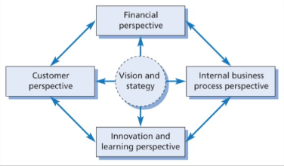

Figure 2. The Balanced Scorecard from Kaplan and Norton, 1992

In order to better depict how the components of the Turning Point Model fit with the Balanced Scorecard approach, PHMDC is working to finalize the following model for its performance management system (see Figure 3).

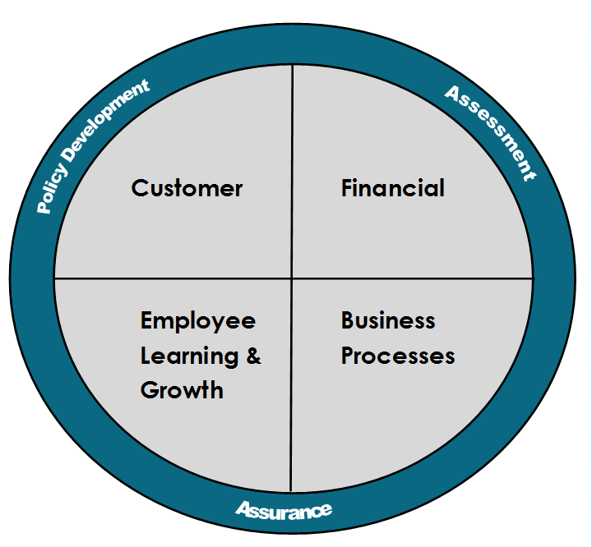

Figure 3. PHMDC Performance Management Model

Performance Objectives, Measures, Targets, and Actions
PHMDC follows our performance management platform (InsightVision) structure in establishing and monitoring agency performance: Objectives, Measures, Targets, and Action (OMTA). Appropriate selection of OMTAs facilitate the evaluation of PHMDC’s efficiency, and increase accountability and transparency within the department.
PHMDC will take a stepwise approach to establishing PM within individual programs to ensure adequate technical assistance can be provided by the PM Implementation Team. Criteria for early adopters of PM include existing PM activities, high level of readiness to adopt PM, and staff capacity to participate in PM training and activities. Managers and their staff will develop objectives, targets, measures, and actions for each program. Identification of meaningful objectives provides the stimulus to strive for better outcomes at all levels.
Objectives and measures are developed first. Objectives may be informed by national, state, agency, or division priorities. Each program submits performance measures for approval using the Performance Measure Proposal Form (Appendix B, Figure 2). The Division Director will review the proposal for relevance to division priorities and significance to the program. The PQI Committee will then assess the proposed measures to ensure the following:

- The measure reflects the objective it is associated with
- The measure is quantifiable
- Data for the measure is readily available
- There is good rationale for selecting the measure, including link to national, state, agency or division priorities
- The measure will provide useful information for evaluating progress and identifying opportunities for process improvement (e.g., QI projects)
- The measure is able to be stratified by key demographics characteristics to assure agency monitoring of differential impact of programs and progress towards objectives for racial and ethnic minorities and other groups
Generally, programs are expected to identify between two and four measures for each objective identified. However, there will be instances where programs may fall outside of this range.
Targets are submitted as part of the Performance Management Proposal Form. Targets are created in collaboration with the epidemiologist, evaluator, or data analyst supporting the program. Programs may choose to identify incremental targets to represent shorter-term improvements in progress towards the objective. Programs may also choose to identify benchmarks, or long-term targets.
Following approval of the Performance Management Proposal Form, the PM Implementation team will onboard the program into InsightVision by facilitating the identification of an InsightVision user responsible for data entry and scorecard retrieval at program meetings and ongoing technical assistance in implementing PM in the program. Appendix B, Figure 1 outlines this process.

Strategic Plan Monitoring and Review
The Strategic Plan outlines the objectives, measures, and targets for Public Health Madison & Dane County and thus is an integral part of PHMDC’s performance management system. The PQI Committee will review measures quarterly and report on the progress of the Strategic Plan’s objectives, measures, and targets on an annual basis. The Accreditation Core Team in collaboration with the Strategic Plan A-Plan Team, will develop a proposal that monitors how revisions are then made to the Strategic Plan, including the additions of new objectives, measures and targets and how the changes are reported. A summary of the Strategic Plan report including progress will be shared with the Board of Health and with PHMDC staff.

Quality Improvement
The PM/QI Plan will incorporate the following QI sections in collaboration with the QI A-Plan Team by December 31, 2018:

- Culture of Quality
- Quality Improvement Model
- Quality Improvement Activities

Training and Support
PHMDC is committed to expanding staff capacity in PM/QI. In order to address training needs and gaps identified in the Performance Management and Quality Improvement Self-Assessments and to build the foundation for a quality-focused culture, the PM/QI Team will develop a detailed PM/QI training plan in 2018. This plan will identify desired Knowledge, Skills, and Abilities (KSAs) and specify plans for developing these KSAs among PHMDC staff. The plan will also identify effective PM/QI training opportunities and methods to meet PHMDC staff needs.

At a minimum, the training plan will address the following staff groups, topics, and approaches:

Staff groups
- Executive Team and Managers
- PQI Committee
- PM Implementation Team
- Program Leadworkers
- All-Staff

Training Topics and Approach
A comprehensive training plan and materials will be developed collaboratively by the PM and QI A-Plan Teams. At minimum, the training will include the following topics:

- Orientation to the PM/QI plan
- Performance Management
- OMTA concepts
- InsightVision Performance Management Platform
- Principles of QI
- Plan-Do-Study-Act cycle
- QI tools and methodologies

A variety of training methods will be utilized, allowing PHMDC staff to access training material in different ways that align with individual learning styles. Training approach may include:

- Web-based modules
- Webinars
- In person seminars
- Breakout sessions at State and National Conferences
- Written guides
- Discussion groups
- Just-in-time training for project teams

Communication
In order to support quality as a usual way of business, PM/QI related news is communicated on a regular basis using a variety of methods to staff, PHMDC Board of Health, and the public. This will keep leaders and staff aware of PM/QI practices and improvement efforts, help increase engagement and buy-in, and help build a PM/QI culture. This section describes how PM/QI initiative information is shared with various stakeholders.

Communication to Key Groups

Executive Team (X-Team) and Managers
A report summary of PM/QI progress and results will be provided regularly at manager meetings. This will include plan and implementation updates, training activities, and QI projects.

All-Staff
- The PM/QI plan will be disseminated and presented to all PHMDC staff with an explanation of expectations and contributions of all staff.
- Updates will be given regularly all staff meetings and division meetings regarding PM/QI plan progress; activities/projects completed, underway, upcoming; evaluation results and subsequent changes; training opportunities; and recognition.
- Updates will be provided regularly through the staff newsletter regarding PM/QI plan progress; activities/projects completed, underway, upcoming; evaluation results and subsequent changes; training opportunities; and recognition.
- QI project storyboards will be shared after project completion, by QI Project Teams and will be posted on “recognition walls” in common staff areas (breakroom, mailroom, etc.) and emailed to staff.
- PQI Committee documents (agendas, minutes) will be saved in the shared drive for review by staff.
- PM/QI documents (agendas, minutes, data tools, storyboards) will be saved in the shared drive for review by staff.

Board of Health
The Board of Health will receive regular updates on PM/QI initiatives including the PM/QI plan, projects, evaluation and subsequent changes.

Public
- Selected PM measures and QI projects will be featured in PHMDC’s annual report, which is posted on the website.
- When appropriate, results of PM/QI initiatives will be communicated to the public through press releases, Pulse stakeholder newsletter, department blog, or social media.

Public Health Community of Practice
Avenues to share success stories and lessons learned with other public health organizations will be explored.

Links to Other A-Plans

Community Health Assessment & Community Health Improvement Plan
The Community Health Assessment (CHA) & Community Health Improvement Plan (CHIP) are integrated processes foundational to the PM/QI Plan. The CHA/CHIP is a systematic examination of the health status indicators for Dane County with the goal of identifying key health issues and inequities. The CHIP will use the information found through the CHA to develop a 5 year plan to impact health in our community. The plan will be inform the development of community-level outcome and strategic objectives and measures for PHMDC’s Performance Management System, InsightVision. InsightVision will support the CHA/CHIP by:

- Assuring ongoing monitoring of measures to assess progress towards community objectives
- Integrating review of community scorecards at stakeholder and partner meetings, including the Board of Health, Health Council, etc.
- Documenting community partnerships
- Centralizing data (including measures and actions) from various partners to document progress towards community objectives

Strategic Plan
The Strategic Plan (SP) guides the department internally to improve the community. The SP is foundational to the PM/QI plan, as it identifies agency-level objectives and measures that push us forward and support us to improve our practice. These objectives and measures will be included in InsightVision. InsightVision will support the SP by:

- Assuring ongoing monitoring of measures to assess progress towards agency objectives
- Integrating review of PHMDC scorecards at stakeholder and partner meetings, including but not limited to the Board of Health

Workforce Development Plan
The Workforce Development (WFD) Plan will establish the agency approach to assuring a competent workforce. This includes a plan for cultivating the next generation of public health workers, matching our workforce with the community we serve, supporting and developing PHMDC staff, and identifying training needs. The WFD Plan will guide the identification of workforce objectives and measures, which will be included in InsightVision. Additionally, all agency training needs, including PM and QI related training will be addressed in the WFD plan.

Monitoring and Evaluation
The PHMDC’s Performance Management and Quality Improvement Plan will be regularly monitored and reviewed in order to ensure its effectiveness in guiding agency performance and improvement efforts. Every two years, PHMDC will conduct an evaluation of the division’s performance management system, including the PM/QI plan. This evaluation will include a performance management and culture of quality review through the administration of a self-assessment in order to solicit internal customer feedback on the system. Following this evaluation, the PM/QI plan will be reviewed and updates will be made as needed.

References and Resources
InsightFormation Inc. https://www.insightformation.com/

Public Health Quality Improvement Exchange (PHQIX) https://www.phqix.org/

Moran, J.W. and G. L. Duffy. 2012. Public Health Quality Improvement Encyclopedia. Washington, D.C.: Public Health Foundation.

National Performance Management Advisory Commission. 2010. A Performance Management Framework for State and Local Government: From Measurement and Reporting to Management and Improving. Retrieved from: http://www.gfoa.org/sites/default/files/APerformanceManagementFramework.pdf

Public Health Accreditation Board (PHAB). www.phaboard.org

Public Health Accreditation Board (PHAB). Public Health Accreditation Board Acronyms & Glossary of Terms, version 1.5. Retrieved from: http://www.phaboard.org/wp-content/uploads/FINAL_PHAB-Acronyms-and-Glossary-of-Terms-Version-1.5.pdf

Public Health Accreditation Board (PHAB). Standards and Measures version 1.5.

Public Health Foundation. “About the Performance Management System Framework” http://www.phf.org/focusareas/performancemanagement/toolkit/Pages/PM_Toolkit_About_the_Performance_Management_Framework.aspx.

Turning Point Performance Management National Excellence Collaborative. 2003. From Silos to Systems: Using Performance Management to Improve the Public’s Health. Retrieved from: http://www.phf.org/resourcestools/Documents/silossystems.pdf

Models and Inspiration for Plan Form and Content
- Jackson County Public Health. Performance Management and Quality Improvement Plan 2017-2018
- Henry County Public Health. Performance Management System
- Jessamine County Public Health. Performance Management System
- City of Chicago Public Health. Performance Management System
- Connecticut Public Health. Performance Management System
- Ventura County, Performance Management System and Quality Improvement Process Plan and Charter
- Washington County Public Health Division Performance Management and Quality Improvement Plan

Appendix A: Glossary of Key Terms

The glossary of key terms is currently under development.

Appendix B: Performance Management Activities Documents

Figure 1: Process for onboarding programs into InsightVision

Figure 2: Performance Management Proposal Form
Performance Measure Proposal Form
Date
Measure scope | ☐Program (specify program):  ☐Division (specify division):  ☐Agency  ☐ Other (specify):
What objective is your performance Measure associated with?

What is your proposed performance measure?

Does the measure reflect the objective?  Performance measures should reflect the Objective. If No is selected, the measure should be revised. | ☐Yes ☐No
Type of measure | ☐Outcome  ☐Process
What is the rationale for selecting this measure?  Performance measures should have a direct connection to a national, state, local, or program standard/priority. | ☐National standard or priority  ☐State standard or priority  ☐CHIP priority  ☐Division priority  ☐Program or grant requirements  ☐Other (specify):
Can this measure be quantified?  Performance measures must be quantifiable. If No is selected, the measure should be revised. | ☐Yes ☐No
Is data for this measure readily available?  Direct access to the data by PHMDC staff allows for timely collecting and reporting of performance measures. | ☐Yes ☐No
Will this measure give useful, actionable feedback? | ☐Yes ☐No
Is this a measure we can influence or affect? | ☐Yes ☐No
Can these data be stratified by key demographic characteristics? Select all that apply. | ☐Race  ☐Ethnicity  ☐Gender identity  ☐Sexual orientation  ☐Other (specify):
What is the target for your measure?

How did you set your target?

What is your baseline?
Please include the year of baseline measurement.

Who is responsible for reporting?
Additional notes or comments

Measure specifications
What is your data source?
What is your numerator?
What is your denominator?
How often are data available for reporting? | ☐Monthly  ☐Quarterly  ☐Bi-annually  ☐Annually  ☐Other (specify)
Why is this measure important?

Division Director approval
Division Director:
Review date:
P-QI Committee Review
Review date:
Proposal ☐Accepted ☐Advise modifications

Comments:

When you have completed this form, please email to email@publichealthmdc.com

Key definitions

Objective: A long-term, systemic change the organization or program is looking to accomplish. For example, reduce the number of people who die from diabetes.

Measure: An indicator of progress toward or away from an objective. Can be operational, performance, or strategic. For example:
- An operational measure might be the number of people screened for diabetes
- A performance measure might be
- A strategic measure might be
Target: A way to show milestones and the rate of progress. For example, we might want to reduce the rate of diabetes from 8.0 per 1,000 to 7.2 per 1,000.

