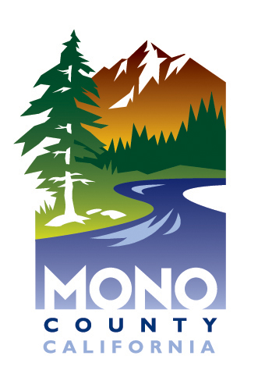

Mono County
Health Department
Strategic Plan
2018 - 2023

V 2018.05.31
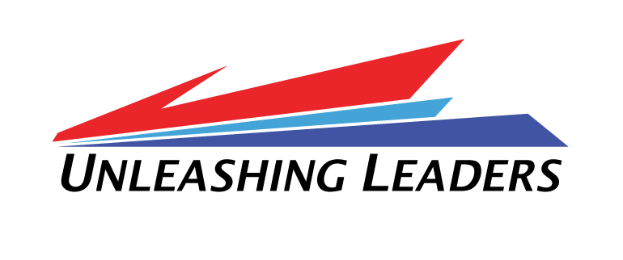
Message from the Director

The Mono County Health Department engaged in strategic planning during the Spring of 2018 to establish a strong foundation with new leadership, develop a guiding mission, vision and values, and adhere to a process of internal growth and improvement. Using the strategic priorities developed by the Mono County Board of Supervisors as an overarching framework, all public and environmental health employees were invited to participate in identifying the department’s goals, objectives, and projects, along with creating the mission, vision and values. The 2018-2023 Mono County Health Department Strategic Plan is a roadmap to improve the health of Mono County residents and visitors, as well as prioritize and strengthen the services provided throughout the community.

Each day, the Health Department works to protect, prevent, and promote. We protect communities from health threats such as contaminated water, foodborne illness, toxic exposures, preventable injury and illness, and the effects of natural and man-made disasters. We prevent disease through immunization, surveillance, investigation, screening, treatment, linkage to care and services, and case management.
We promote wellness thought outreach, education, policy and program development, and collaboration with community partners.

As opportunities and challenges continue to shift in the public health landscape, our department needs to maintain flexibility and change to meet the needs of the County. Similarly, this plan is adaptable, and will be revisited regularly as future projects and resource allocation change with legislative mandates and funding streams. This strategic plan reflects our department’s highest priority areas for improvement and wellness, rather than the multitude of essential projects being addressed on any given day to maintain community and environmental health.

Our department is committed and invested in this strategic planning process, and excited about the future opportunities initiated. Through our collective values, finding purpose, and contributing to make a positive impact on the health of the community, Mono County Health Department will fulfill our mandate to protect, prevent, and promote.
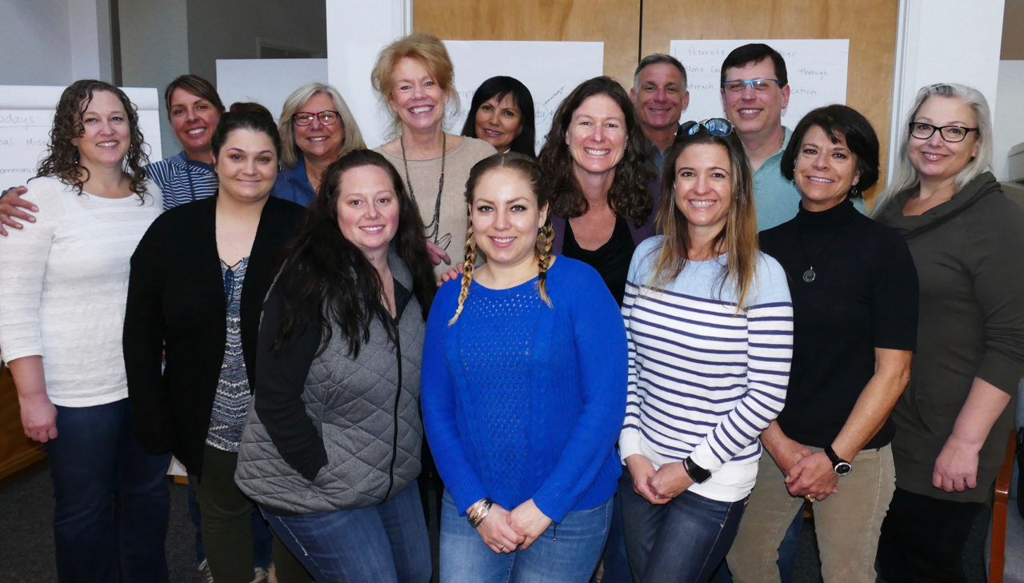
Sandra Pearce, MS, RN, PHN, CNS
Mono County Director of Public Health

Strategic Planning Session March 26-27, 2018
Organization Strategy Map

The stable elements of the Strategic Plan have been organized into a one-page visual Strategy Map. This illustrates the department’s service to the County in alignment with goals and values.

The mission and vision summarizes at the highest level why Mono County Health Department is here and what kind of organization it aspires to be. Some activities may not directly impact the mission, but all departmental work contributes to achieve the mission. While there is always room for growth, the department celebrates progress toward achieving its mission.

In order to achieve the mission and vision, the department works to balance performance across five strategic goals. The Health Department goals align with the strategic plan for Mono County. Within each of these goal categories, more specific objectives for 2018-2020 have been identified.
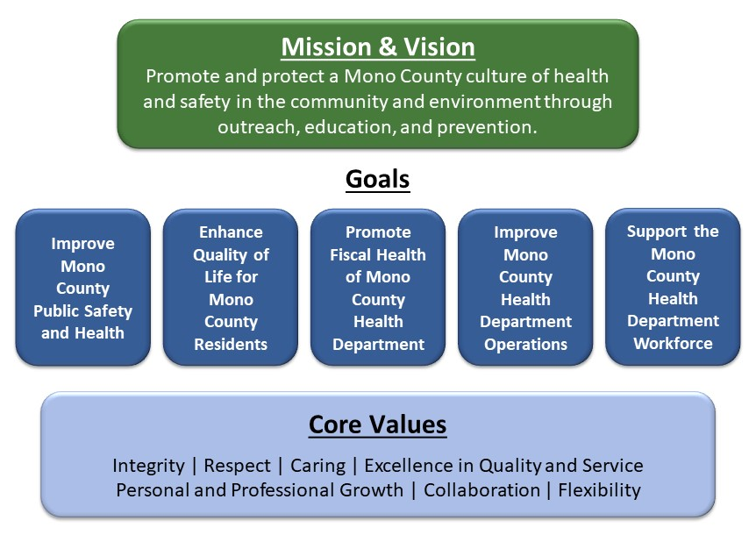
To achieve these goals in an ever-changing environment, work projects will be managed using a few dynamic tools. Progress towards these goals will be assessed across a set of Key Performance Indicators on a Performance Dashboard. Services will be optimized for Health Department customers through a Service Portfolio. Service improvements will be made through a dynamic set of projects that are managed as a Prioritized Project Portfolio.

How the Health Department team treats customers and one another is just as important as what projects are achieved. The core values set the standard for how our department will act along the way, in conducting themselves as a team as well as interactions with the community.

Strategy Map

Customer/Stakeholder Community Map

The Customer Community Map is a simple, summary illustration of the key types of stakeholders the Mono County Health Department serves.

Customer/ Stakeholder Types | Description and/or Example Organizations
Visitors and Residents | Individuals directly receiving or benefiting from Health Department services
NGOs & CBOs | Wild Iris, First 5, Community Service Solutions, IMACA, Mammoth (Alterra) Resorts, Faith Based Organizations
Community Health & Education Partners | Mammoth Hospital and Clinics, Toiyabe Indian Health Project, Pioneer Home Health and Hospice, Schools
Government | Local: Behavioral Health, Social Services, Community Development, Fire Districts, Law Enforcement, EMS, Town of Mammoth Lakes, Board of Supervisors, Town Council. Regional: Inyo County, ICEMA, Region VI RDMHS. State: CDPH, DHCS, CalEPA, CAlFire. Federal: USDA, DHS, FEMA, HRSA, CDC. Tribal: Toiyabe Indian Health Project, Benton Paiute Tribe, Bridgeport Indian Colony
Media | Print: Mammoth Times, The Sheet, Sierra Scoop, El Sol Del La Sierra. Radio: KBOV, KIBS, KMMT, KSRW, KRHV
Regulated Communities | Food facilities, Gas stations, Public Water Systems

Alignment with Mono County Strategic Plan

As the Health Department falls under the umbrella of Mono County, it plays a vital role in maintaining and enhancing the environmental and economic integrity of the County. The department leverages effective partnerships across all levels and collaborates with many agencies and organizations. The Health Department designed their mission, vision, goals and values to align with and contribute to the larger agency strategic goals. The Mono County Strategic Priorities are:

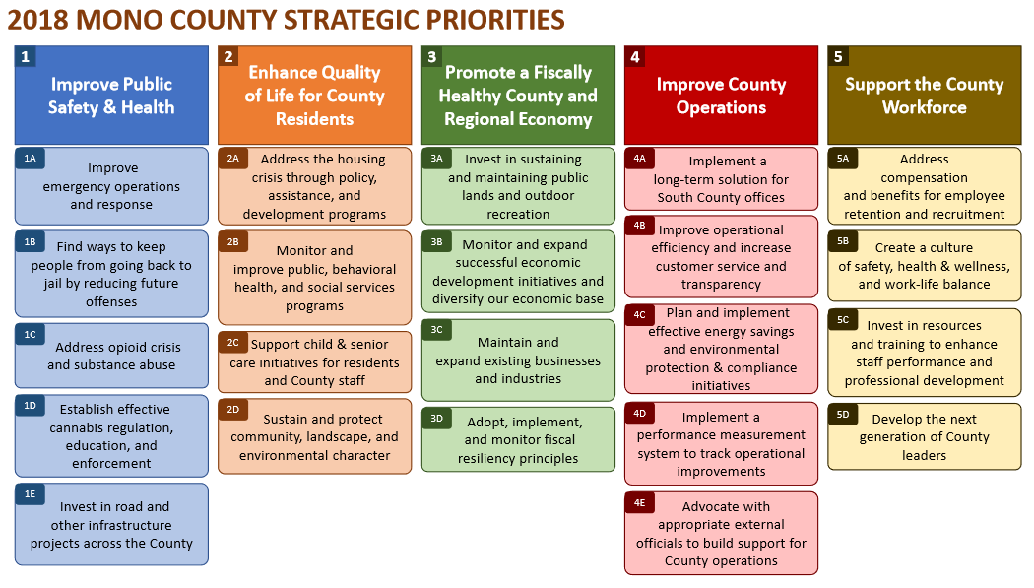

Goals and Objectives

The Health Department strategic goals describe long term categories of achievement. Within each of these goals, there are more specific, short term objectives defined. These objectives describe the major outcomes the department is stiving to achieve over the next 6 to 18 months. Specific, quantifiable targets will be set and progress tracked against these objectives in the Performance Dashboard. How work is managed will be adjusted through the Service and Project Portfolios to achieve these objectives. Because these align directly with the Mono County Strategic Priorities, the numbering has been kept consistent with the chart on the previous page, to make these connections readily visible.

- Improve Mono County Public Safetly and Health
1A: Improve Emergency Operations and Response
1C: Address opioid crisis and substance abuse
1D: Establish effective cannabis regulation, education, and enforcement

- Enhance Quality of Life for Mono County Residents
2B: Monitor and improve public, behavioral health, and social service programs

- Promote the Fiscal Health of Mono County Health Department
3D: Adopt, implement, and monitor fiscal resiliency principles

- Improve Mono County Health Department Operations
4B: Improve operational efficiency and increase customer service and transparency

- Support the Mono County Health Department Workforce
5B: Create a culture of safety, health & wellness, and work life balance
5C: Invest in resources and training to enhance staff performance and professional development

Dynamic Strategic Management

Strategic Planning is an event, however Strategic Management is an ongoing process. The Strategic Map developed is divided into 3 components, enabling a dynamic system that can be adapted as needed. Mono County Health Department’s Strategic Plan has been set up using the following tool sets and disciplines to be good stewards of the public resources allocated to the department.

- Performance Dashboard: This is a set of Key Performance Indicators (KPIs). Each KPI sets specific target ranges and measures progress against goals and objectives. The management team, updates and reviews this on a monthly and quarterly basis to maintain accountability.
- Service Portfolio: This consists of the high-level service categories and their main sublevel service components. It is used to organize how resources are allocated, monitor service level agreements, and track investments.
- Prioritized Project Portfolio: This contains the active and upcoming projects. A project is a temporary effort that will either create a new service or change an existing service. This is used to understand the demand for changes, determine relative priorities to guide resource allocation and workforce planning, and to track progress towards completion. Project Management standards are used to define, initiate, manage and close projects.

Acknowledgments

The Strategic Plan was created as a group effort under the leadership of the Mono County Public Health Director, facilitated by Unleashing Leaders and funded through the NACCHO Accreditation Support Initiative (ASI) Grant. An environmental scan questionnaire was emailed to all Health Department employees in March 2018, and responses were gathered for baseline data and to design the 1 ½ day strategic planning session.

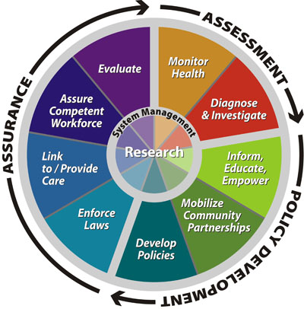
During the strategic planning session, which took place on March 26-27, 2018, small and large group discussions were utilized to evaluate the landscape both within and outside the Health Department. The summary of information from the environmental scan questionnaires was used as a starting point to understand the current environment, with all the challenges and opportunities presented. Grounded in that reality, a compelling future was visualized, aligning the department’s goals and objectives with the Mono County Strategic Priorities. Using these priorities and the 10 Essential Public Health Services as guidance, resources and ideas for improvement were organized into what became the Service and Project Portfolios, and efforts were prioritized to yield the best return on investment for Mono County. Key Performance Indicators were then developed to ensure a process of measuring success as well a method to correct the course as needed along the way. During the strategic planning session, the department’s mission, vision, and values were developed using Rapid Organization Unit Statements, a process of collaboration and breakout sessions.
10 Essential Public Health Functions

Using this Strategic Plan, the department will continue to work to optimize and deliver on its mission for Mono County. Mono County Health Department would like to thank the following people for being part of the strategic planning process:

Mono County Health Department Participants:
Dustlyne Beavers, Dr. Tom Boo, Kim Bunn, Nancy Cruz, Deb Diaz, Amber Hise, Jill Kearny, Nancy Mahannah, Louis Molina, Sandra Pearce, Shawna Pettigrew, Leah Roman, Shelby Stockdale, Bryan Wheeler, and Olivia Wilson

Mono County Administrative and Contract Support:
Leslie Chapman (CAO), Stacey Simon (County Council), Janet Dutcher (Finance Director), and Jay Sloan (Risk Manager)

Strategic Planning Consultant Unleashing Leaders:
Lee Scott (CEO) and Jason Roberts (Change Agent)

NACCHO ASI Grant Support:
Melissa Mayer and the Accreditation Support Initiative (ASI) Team from the National Association of County & City Health Officials (NACCHO), Public Health Accreditation Board (PHAB), and Centers for Disease Control and Prevention (CDC)

