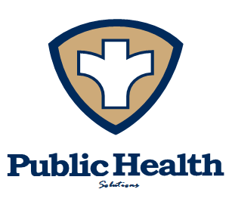
PUBLIC HEALTH SOLUTIONS
995 E Hwy 33, Suite 1
Crete, NE 68333
Phone: 402-826-3880 Fax: 402-826-4101 Website: www.phsneb.org

IMMUNIZATION PROGRAM FEEDBACK ANALYSIS

This report serves as documentation of client feedback pertaining to the Immunization Program at Public Health Solutions.

Collection of Feedback:
- Client Experience surveys were distributed in both Spanish and English to all clients utilizing the immunization services at PHS.
- Surveys were created using examples from other health departments and evaluated for appropriate health literacy levels.
- Surveys were collected for a period of four weeks during a busy season for immunizations
- Clients were asked to complete the surveys, and we had a return rate of approximately 65%

Analysis of Feedback:
- Survey results were compiled and presented to the Domain Team for PHAB Domain 9
- The majority of respondents were female, and 75% of the respondent surveys were completed on English forms.
- Clients noted immense satisfaction with staff in the front office and with the nurses providing the immunizations
- Clients noted a high wait time for services.

Conclusions:
- More data from Spanish-speaking clients would be helpful, as they make up the majority of our immunizations clients
- Wait time is an issue that could use some attention moving forward
- Our staff is well trained in friendly client-interaction, and now we can focus on more detailed aspects of our service delivery.

Report compiled by:
Domain 9 Team
Accreditation Coordinator

March 16, 2017

