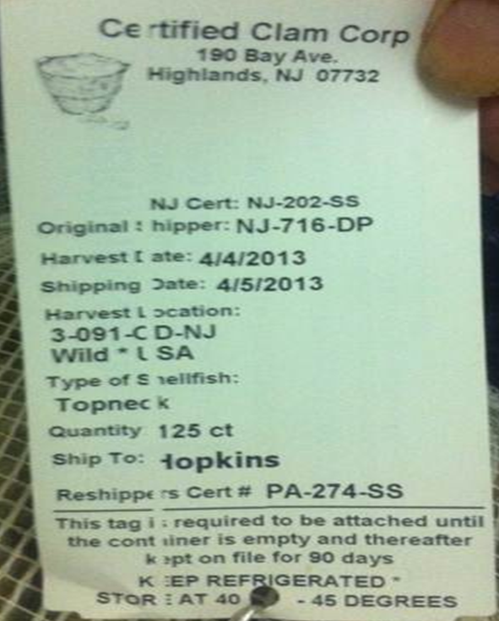



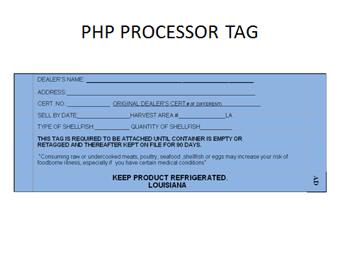 Tag from depuration plant.

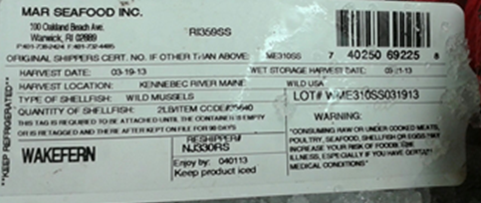 Normal tag (this one is from an approved wet storage facility. Check info:

* Cert. dealer’s name, address, cert #
* Original dealer if other than the shipper
* Harvest date
* State designated harvest area with state abbreviation
* Type and quantity of shellfish
* Reshipped to (optional)
* Keep 90 days /Keep Refrigerated
* Health Advisory (could be on back)

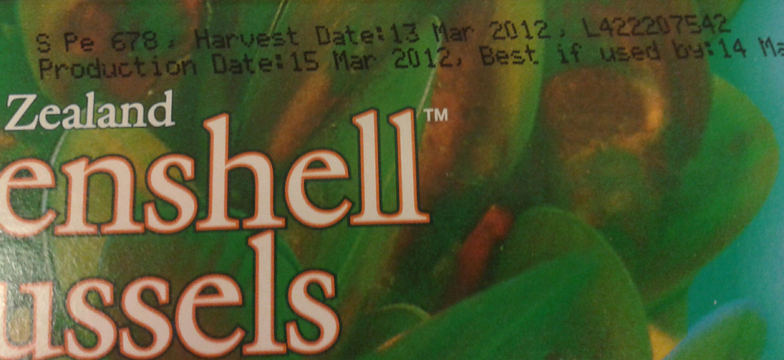

Tag not required on frozen mussels- must be

Information stamped on box:

* certified dealer number
* harvest information
* process or lot code
* name and address of the firm

