Barry-Eaton District Health Department

An Accredited Public Health Agency
www.barryeatonhealth.org

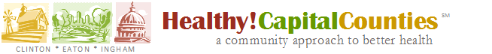

Focus Group Participation
& Incentive Receipt Agreement

I, _________________________________________________
(print name)

agree to participate in today’s focus group on health.

I understand the following:
- My name and other identifying information will be held confidential.
- Today’s focus group will be recorded using audiorecording and/or videorecording equipment to allow the project staff to accurately report what was said during the focus groups. These recordings will be destroyed once the project is complete.
- We may directly quote what you say in a publication, but you will not be personally identified.
- The results of these focus groups will be one source of data used to determine the community health needs of persons living in Clinton, Eaton, and Ingham counties.
- Your decision to participate in a focus group will not be used to determine your eligibility in any program offered by the health department or the Healthy! Capital Counties partner agencies.

I certify that I have received the following incentive item for my participation:

$25 Meijer Gift Card

________________________________________ _______________________
Signature Date

