***Quality Improvement Plan***

**Berrien County Health Department**

2017

Table of Contents

Introduction 2

Key Terms 2

Description of Berrien County Health Department’s Culture of Quality 4

Link to Other BCHD Plans 6

Structure of Quality Improvement & QI Team 6

Project Identification 8

Quality Improvement Training 9

Quality Improvement Goals, Objectives, and Implementation 9

Monitoring and Evaluation 10

Communication 10

Introduction

The Berrien County Health Department (BCHD) is committed to quality improvement as a mechanism to:

* Improve health outcomes through data driven improvements;
* Use resources more efficiently;
* Prioritize and engage customer needs and feedback; and
* Innovate in public health

The need for a quality improvement plan was a top priority for staff participating in department-wide strategic planning efforts in 2016. Quality improvement at the BCHD is an integral part of the organization and is a continual cycle of measurement, analysis, and improvement.

This current plan builds on BCHD’s goals to consistently work toward the enhancement of the organization’s performance in order to achieve improved population health outcomes. Additionally, this plan is an opportunity to enhance the department’s accountability to progress, reinforcement of what is working well, and improvement in those areas of implementation which are lacking.

This plan was created for implementation of Quality Improvement and the establishment of a culture of quality at the Berrien County Health Department. Its creation was supported through technical assistance from the Michigan Public Health Institute.

Key Terms

**Culture of Quality –** The infusion of quality improvement into the way business is completed daily; it is when staff continuously consider how processes can be improved, and QI is no longer seen as an additional task, but a frame of mind in which the application of quality improvement is second nature.

**Quality Improvement** - The process that links knowledge, structures, processes and outcomes to enhance quality throughout the department with the intent to improve the level of performance of key processes and outcomes.

**Continuous Quality Improvement** - The ongoing effort to increase the department’s approach to manage performance, motivate improvement, and capture lessons learned. It is the ongoing effort to improve efficiency, effectiveness, and quality, performance of services, processes, capacities, and outcomes.

**Quality Improvement Plan** – outlining BCHD QI goals and objectives, this living document provides direction and structure for QI efforts. The BCHD strategic plan should inform the QI plan, and QI efforts should align with strategic priorities.

**Plan-Do-Study-Act Cycle** - PDSA is an iterative, four-stage problem-solving model for improving a process or carrying out change. PDSA stems from the scientific method (hypothesize, experiment, evaluate). A fundamental principle of PDSA is iteration. Once a hypothesis is support or negated, executing the cycle again will extend what has been learned.

**Performance Management** - Performance management is the strategic use of performance standards, measures, progress reports, and ongoing quality improvement efforts to ensure an agency achieves desired results. The ultimate purpose of these efforts is to improve the public’s health by actively using performance management data.

**Quality Improvement Team** – A team or committee within the LHD that is charged with guiding quality improvement efforts and work throughout the department.

**Staff Experts (Subject Matter Experts)** – These are individuals who can contribute significant knowledge about a program, process, or operation that has been identified and undertaken as a QI project. Their role is to provide background information and data related to a given QI project’s focus, and to actively work with management to implement any improvements identified as effective solutions through PDSA.

**Measures –** Also referred to as indicators; these terms refer to numerical information or data that quantifies input, output, performance and outcomes. Measures can be simple (referring to one action or a composite).

**Output** – Refers to the level or amount of effort or activity put into a project. Output can refer to hours, products, or other productivity that is required to achieve the intended outcome.

**Outcome** – The term outcome refers to the results intended or achieved. The intended final results can be referred to as ultimate outcome.

**Strategic Plan** – The result of a deliberate and intentional decision making process that defines the LHDs priorities and where the LHD is going that is based off of the common understanding of the mission, vision, and values of the Department.

**Process** – A set of linked activities with the purpose of prolonging a product, service, or outcome. Process may involve people, machines, tools, techniques and materials in a sequence of defined steps. Process may also include general understanding of reaching a desired end.

**Project Team** - A multidisciplinary group of individuals brought together to address a QI project and who contribute through the sharing of their knowledge, experiences, skills and perspectives of the project focus at hand.

**Project Lead** – A member of the Project Team, this individual is responsible for driving the project work forward to the achievement of the identified aim statement. The leader ensures the group completes each step of the PDSA cycle.

**Quality Tools** – Quality tools are designed to assist a team when solving a defined problem or project. Tools will help the team get a better understanding of a problem or process they are investigating or analyzing.

**Quality Assurance** – Quality Assurance is the maintenance of a set or desired level of quality in a service or program completed through planned and systemic activities to assure quality requirements are met.

**Quality Control** – Quality Control is a procedure(s) for the purpose of ensuring that delivered services and programs are being operated in a way consistent with department or client defined quality criteria.

**Quality Planning** - Quality Planning is the structured process for developing services and programs so as to meet the needs of the population served and department quality standards.

Description of Berrien County Health Department’s Culture of Quality

**Current State of Quality**

The BCHD’s current approach to quality and quality improvement is somewhat sporadic. Many staff members are concerned about quality and are continuously tweaking processes to improve quality, however these attempts are most often not systematic and their impact remain unstudied. Staff members make their best guess about what is working, but there is little data to determine the impact of their efforts. These efforts also vary between programs and service areas.

However, through a commitment to build a quality culture and to better institutionalize quality improvement practices the Department has made this transition a priority focus area in its 2016-2020 Strategic Plan. A quality improvement team was established in the spring of 2017, consisting of staff representation both horizontally across program areas and vertical across all levels of department leadership. Additionally, the Department participated in a regional based and lead quality improvement training series with 4 other local health departments. Ten members of the QI team were able to participate; the team completed its first QI project during this 8 week period as well.

Past Successes:

* The Berrien County Health Department (BCHD) implemented Quality Improvement projects with the objective of increasing efficiency of services, increasing cost effectiveness of services, and increasing customer satisfaction. The two specific areas targeted for these outcomes were Children’s Special Healthcare Services and Restaurant Inspections. Both of these programs were struggling with lagging response times to return client calls and/or return for follow-up services, and believed that the difficulties stemmed from inefficient tracking systems and procedures. These projects were able to move forward at that time (2009) through the support of a grant from the Robert Wood Johnson Foundation.
* The Berrien County Health Department – Nurse Family Partnership Program, through the support of MIECHV funding and the Michigan Public Health Institute are required to complete two local CQI projects annually as well as to maintain participation in a regionally based project. This has developed a strong understanding for the benefits and importance of quality improvement within their program staff and has served to make program services and relationships better.

**Desired State of Quality**

The purpose of the QI plan is to develop a culture of quality in the Berrien County Health Department. BCHD is working towards a department-wide culture of quality in which all staff members understand the need for quality improvement as well as the key questions and guiding principles of quality improvement.

Future Direction Includes:

* PDSA cycle is used on a regular basis in all service areas and theories of improvement are tested one at a time; the entire process is documented appropriately
* A continuation of a QI Team that meets regularly and completes at least two projects per year
* BCHD staff feel more autonomy and control over their work processes by understanding how to make QI work within our organization and their programs
* QI team that is trained in PDSA method of QI and other necessary skills for implementing and sustaining projects
* A BCHD team (inclusive of all staff) that is engaged in QI projects on the processes they work within
* Quality Improvement Projects are identified through the integration of customer and staff feedback, strategic planning and workforce development needs

|  |  |
| --- | --- |
| **BCHD Culture of Quality** | |
| QI is fully embedded into the way the department does business, across all levels and services. Leadership and staff are fully committed to quality and results of QI efforts are communicated internally and externally. Even if leadership changes, the basics of QI are so ingrained in staff that they seek out the root causes of problems. They don’t assume that an intervention will be effective, but rather they establish and quantify progress toward measurable objectives. | |
| **Human Side Characteristics** | **Process Side Characteristics** |
| * Self-assessment and trainings are ongoing * Problems are “gold” * Top-down and bottom-up approach to QI is prevalent * Results are reported to staff, stakeholders and customers * QI competencies and action plans are incorporated in job descriptions * Role modeling is common   *Caution: digression is a lot easier than progression.* | * QI is integrated into all agency plans * Data and tools are used in everyday work * Customer is front and center * Innovation is common * Agency operations are outcome driven * Return on investment is being demonstrated * QI is included in performance evaluations |

*\*Adapted from NACCHO’s Quality Improvement Roadmap*

Link to Other Berrien County Health Department Plans

Development of Quality Improvement Plan is a goal within the **2016-2020 Strategic Plan.**

A **Department Performance Management Plan** will map out the methods for monitoring the progress of the BCHD towards the accomplishment of its goals and objectives as laid out in the department’s strategic plan. QI will be an important method in achieving those goals, and metrics indicating the use of QI for process improvement will be included in the performance management system.

Quality Improvement work in BCHD will be targeted at moving the metrics that matter most to our organization as noted in the plans identified above and through **customer and partner feedback**.

Quality Improvement will also be linked to the **BCHD Workforce Development Plan** as this will ensure that essential opportunities for QI knowledge and skill growth is also institutionalized for staff members—particularly those on the QI team.

Structure of Quality Improvement

BCHD has a QI Team that is comprised of several staff members representing a variety of programs and services areas. There is also broad representation across the hierarchy from administrative level up through senior leadership. This was formed and sanctioned by the Health Officer. Membership on the QI team is voluntary.

The QI team is responsible for championing the cause of quality improvement and being the staff experts on how to conduct QI. They will take the lead and help move all BCHD QI projects forward. For each project, one member of the team will be designated as the Project Lead and other team members will fill in various roles on the Project Team. There will also need to be Staff Experts who are not members of the QI team, but will join the Project Team because they work within the targeted process. Project Leads are responsible for ensuring that Staff Experts who join the Project Team receive just-in-time training on the PDSA cycle and other QI tools as appropriate. This will aid in the workforce development goals of the QI Plan and direct BCHD to the desired future state of a Culture of Quality.

QUALITY IMPROVEMENT TEAM

**Roles and Responsibilities**

The purpose of the QI Team is to review proposed QI initiatives, facilitate QI initiatives within their work area, monitor progress and report on the progress made throughout the department. The QI Team Charter is located in this plan’s appendices.

Examples of the responsibilities include:

* Commitment to receive QI training
* Develop a prioritized list of QI initiatives for the Department on an annual basis and monitor their progress on a monthly basis
* Develop a plan to move toward a culture of QI, monitor its implementation on a monthly basis, and assess overall progress and revise the plan accordingly on an annual basis
* Develop a plan for soliciting customer input, monitor its implementation on a monthly basis, and assess overall progress and revise the plan accordingly on an annual basis
* Identify opportunities to adapt and adopt improvements throughout the department and develop plans to implement them
* Ensure that the Department’s communications plan is inclusive of a means to report on the agency’s QI efforts
* Serve as an ambassador throughout the department for QI initiatives

Standing agenda items include, but are not limited to:

* Update on QI initiatives
* Update on workforce development efforts
* Update on customer satisfaction assessment efforts
* Update on QI culture efforts
* Staff communications about QI
* Recognition of QI events
* Decision-making
* Budget needs
* Administrative support needs

**Meetings:**

The QI Team will meet monthly during a lunchtime oriented period to ensure a diverse group of staff are able to participate and to eliminate excess conflict with differing program schedules.

**Staffing and Administrative Support:**

As stated previously, staffing of the QI Team will be comprised of staff members from each of the agency’s divisions and includes management support. The Deputy Health Officer will be a member of the QI Team.

**Budget and Resource Allocation:**

Currently, the department does not have a specific budget line item for quality improvement, but is committed to the release-time for staff to participate in QI activities and training opportunities. The Department has been successful in securing grant funding to develop and implement its QI plan and will continue to seek out funding to sustain and enhance its activities.

Project Identification

Department quality improvement projects will be identified by BCHD Leadership, QI Team members and/or any staff member of the BCHD department. Methods for identifying projects will be through department reporting mechanisms including but not limited to program evaluations and reports, customer and staff surveys, and leadership and staff observations and recommendations. Additionally, QI Projects will be prioritized that are identified through working towards the goals outlined in the Department’s Strategic Plan.

When a project is identified, the identifying BCHD staff member will complete the QI Project Proposal (included in plan’s appendices). This proposal will be submitted to the QI Team for review and so that a team may be established. The QI Team will review and provide feedback based on: factors within the department’s control, ease of change, number of staff required and current capacities, resources required, outcome alignment with workforce development and strategic plan.

A Quality Improvement folder has been created on the Department’s shared drive. This location will be utilized to organize all projects underway in the department (in individually labeled subfolders) and will ensure historical knowledge of department QI efforts is maintained.

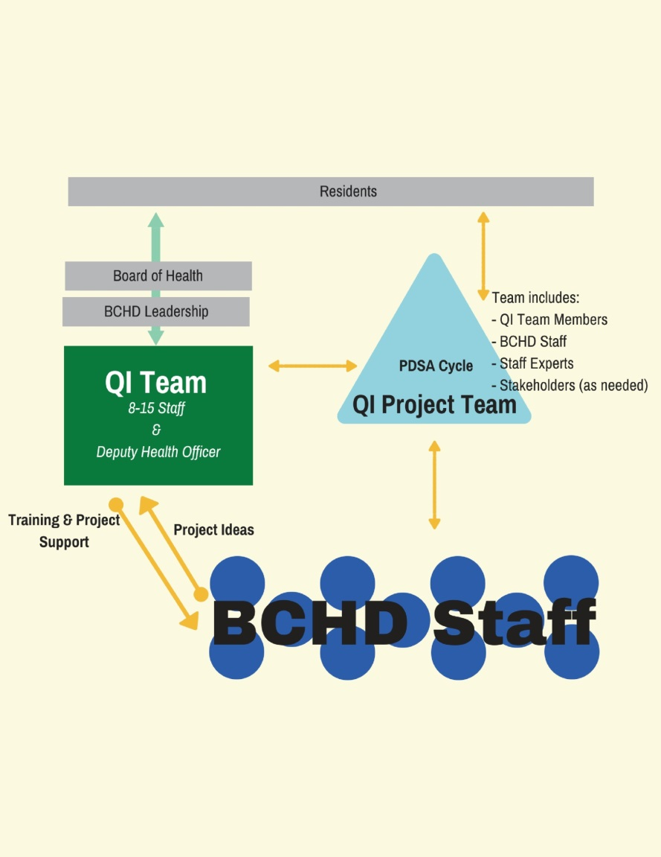

Quality Improvement Training

QI Training will take place department-wide and in the following manner:

* QI team will determine a yearly education plan for themselves and for staff. Time at QI Team meetings and at staff meetings can be utilized as training opportunities if warranted
* All new staff will be oriented to the concept of quality improvement, its roles and process, to the QI Plan and to available resources. This will be reflected in the orientation checklist.
* Advanced and continued training will be provided to the QI Team members on an ongoing basis, through such opportunities as face to face trainings at the State, through webinars, through review of appropriate literature, and by presentations by teams members at team meetings
* All training that is planned and provided will be documented.

Possible training resources may be available from, but are not limited to the following: State Health Department, NACCHO, PHQIX, OSU Online training modules,

Initially, the Deputy Health Officer will serve as Department-wide trainer. However, all QI Team members will be given opportunity to increase their knowledge and training abilities to ensure ample support to QI training is available in the department.

Quality Improvement Goals, Objectives, and Implementation

The FY 2018 -2021 Quality Improvement goal of the department is to achieve a culture of long-term quality improvement throughout the department.

Berrien County Health Department’s goals and objectives including activities, outcome targets, timeframes and department designated responsibility to assure successful achievement of each is outlined in the **Quality Improvement Goals and Objectives – 2018** document (Appendix I).

*Note*. The QI Council will update Goals and Objectives on an annual basis, targeting November of each year to ensure work progresses and goals and objectives are responsive to the current needs of the department.*

Monitoring and Evaluation

The department is committed to providing ongoing support and monitoring for all QI projects within the department. For this purpose, all QI projects in the department will have no less than one QI team member as a part of the QI project team. This QI Team member will provide support and partnership as well as a direct link to the QI Team for ongoing support; project updates and ongoing monitoring will be discussed monthly by the QI Team. QI works (trainings, projects, etc…) will be reviewed at monthly BCHD Leadership Team meetings for their consideration, action and ongoing monitoring of department progress and improvements as well. The Health Officer, will assure that regular reports and updates are provided to County Administration and the Board of Health in manners as deemed appropriate.

Quality Improvement Team will review all goals and objectives annually and make changes, updates as necessary. Additionally tracking and evaluation will be encompassed in the Department’s Performance Management System.

Communication

The QI communications plan, developed by the QI team and revised annually, will assure that all department staff, Administration, Board of Health and Partners are regularly informed of the QI activities with the department. Means for providing these updates and for ongoing QI activity reporting may include quarterly staff meetings, program meetings, advisory board meetings, quarterly e-newsletter, department website and social media, display of project storyboards in staff areas, department annual report and community newsletters. Quality Improvement reports and project success may also be shared through the BCHD Public Information Office in the form of press releases and conference presentations.

Sustainability

The Berrien County Health Department is committed to the ongoing development and achievement of a culture of quality for all department staff.

QI Team will pursue sustainability of a QI culture which fosters QI activities and consequently approves all processes to deliver quality services to our community. Strategies utilized to build this sustainability include:

* + Including QI language into position descriptions and evaluation as appropriate
  + Inclusion of QI methods and tools on orientation checklist for new employees
  + Engagement of employees in the QI process through opportunities to suggest improvement projects and to serve on project teams
  + Ongoing education on QI initiatives, processes and tools
  + Revised policies and procedures to reflect change coming for the QI process to make them permanent

Appendices

1. Quality Improvement Goals and Objectives for 2018
2. Quality Improvement Project Proposal Template
3. Quality Improvement Project Report Template
4. Quality Improvement Policy
5. Quality Improvement Council Charter

**APPENDIX I**

**Quality Improvement Goals and Objectives for 2018**

|  |  |  |  |
| --- | --- | --- | --- |
| **Goal 1: Support the development and achievement of a culture of quality throughout the Berrien County Health Department** | | | |
| **Objective 1: Increase knowledge of BCHD Staff in regards to quality improvement and performance management by December, 2018** | | | |
| **Activities** | **Outcome(s)** | **Timeframe** | **Responsible Persons** |
| Incorporate quality improvement and performance management overview into staff onboarding process | 100% of new staff receive QI training within 60 days of hire. | By end of July, 2018 | QI Team, BCHD Leadership Team |
| Create and implement a QI Training Plan for Department | 95% of staff receive QI training annually | By end of July, 2018 | QI Team |
| Assess Staff annually of their awareness of QI and QI tools | 95% of staff complete annual QI assessment | By December, 2018 | QI Team, BCHD Deputy Health Officer (Workforce Dev. Overlap) |
| **Objective 2: Implement at least 2 formal QI projects per year as identified through the performance management system** | | | |
| **Activities** | **Outcome(s)** | **Timeframe** | **Responsible Persons** |
| QI team to review strategic plan work and performance management system quarterly | 2 projects are identified annually for department QI efforts | By March, 2018  By June, 2018  By September, 2018  By December, 2018 | QI Team |
| **Objective 3: Attain PHAB standards for Quality Improvement and Performance Management by the end of 2018** | | | |
| **Activities** | **Outcome(s)** | **Timeframe** | **Responsible Persons** |
| Update Department Quality Improvement Policy | BCHD Policy institutionalizes QI department-wide | By February, 2018 |  |
| Create Department Performance Management Policy | BCHD Policy institutionalizes performance management department-wide | By June, 2018 | Deputy Health Officer, BCHD Leadership Team, PM Consultant |
| The QI Team will review PHAB Domain 9 on an annual basis and identify areas to meet Standard 9.1 | By December 2018, BCHD will substantially meet all of the standards in PHAB Domain 9.1 | By December, 2018 |  |
| **Objective 4: BCHD will be able to provide at least one example of how customer/ stakeholder feedback was collected and analyzed for quality improvement purposes by December, 2018** | | | |
| **Activities** | **Outcome(s)** | **Timeframe** | **Responsible Persons** |
| Formalize Customer Satisfaction survey and process | All BCHD programs will receive feedback from customers. | By December, 2018 | QI Team |
| Have BCHD programs implement survey | At least 50% of BCHD Programs use on a regular basis | By December, 2018 |  |

*Note*. The QI Council will update Goals and Objectives on an annual basis, targeting November of each year to ensure work progresses and goals and objectives are responsive to the current needs of the department.*

**APPENDIX II**



**APPENDIX III**



**APPENDIX III**

