The Public Health Foundation of Columbia County
Performance Management System*
February 2018

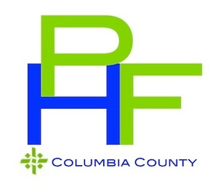

*Adapted from Turning Point “From Silos to Systems: Using Performance Management to Improve the Public’s Health”

The Public Health Foundation of Columbia County’s (TPHFCC) Performance Management System will include the following components:
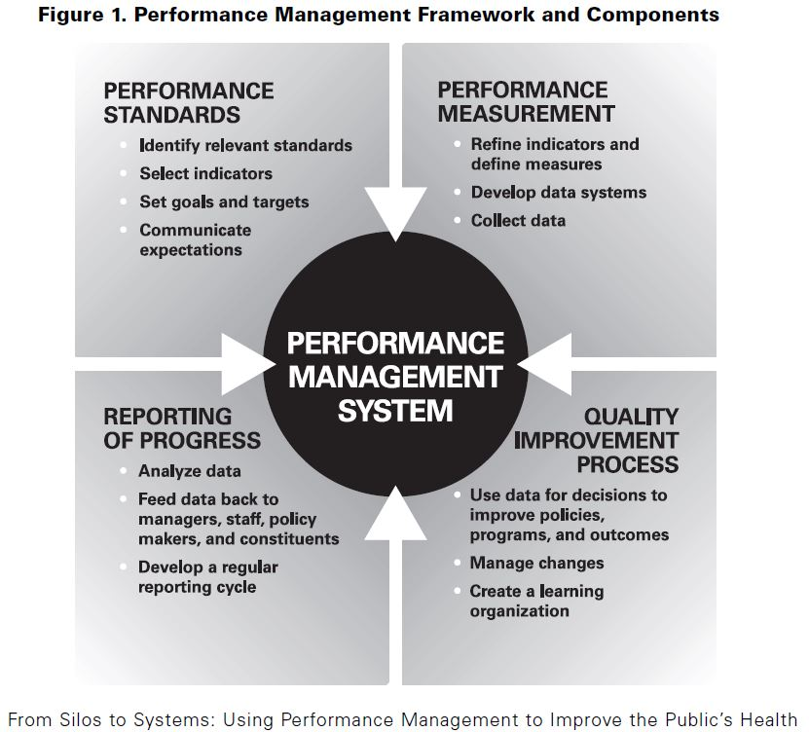
- Performance standards – establishment of organizational or systems performance standards, targets, and goals to improve public health practices.
- Performance measures – development, application, and use of performance measures to assess achievement of such standards.
- Reporting of progress – documentation and reporting of progress in meeting standards and targets and sharing of such information through feedback.
- Quality improvement – establishment of a program or process to manage change and achieve quality improvement in public health policies, programs, or infrastructure based on performance standards, measures and reports.

In the summer of 2017, The Public Health Foundation of Columbia County conducted a performance management self-assessment. The results showed were not wholly unexpected as the results of those who completed showed that performance management was in its infancy within TPHFCC. TPHFCC was doing relatively well in quality improvement, but was not excelling in the other categories. Those who analyzed the data recommended that the agency begin in educating staff about the components of a performance management system before integrating it with other TPHFCC strategic documents like the Strategic Plan and the QI Plan.

Integrating Strategic Documents
TPHFCC has various strategic documents that guide its work. They include, but are not limited to:
- Strategic Plan: Updated on a 5-year cycle, this document guides the strategic goal-making of programs and administrative areas within TPHFCC. Priorities in the Strategic Plan are chosen based on local data from sources like the Community Health Assessment, local community service agencies, and State data collection.
- Community Health Assessment: This document is the collection of local and regional data collected by a partnership between Columbia Pacific CCO and local public health entities. This document is current for three years and is redone as it lapses.
- Community Health Improvement Plan: This document is created in partnership with community stakeholders based off of the data collected by the Community Health Assessment. Priority areas are determined by the data and then strategies and objectives are selected based off of community input.
- Workforce Development Plan: This document describes the skills, training, and staffing needs required for TPHFCC to perform as a modernized public health service provider. This document changes to reflect the changing landscape of public health.
- Performance Management System: This system is used to determine the progress of the strategic goals outlined in the Strategic Plan. Areas that need assistance in improving outcomes utilize the Quality Improvement Plan.
- Quality Improvement Plan: This document guides the improvement process for identified projects. This document guides the Quality Improvement Committee as the conduct their roles and responsibilities.

TPHFCC has a Quality Improvement Committee that will serve in an ad hoc role as the Performance Management Review Board in conjunction with on-going discussions within the supervisors’ meetings. To review the make-up of the QI Committee, please refer to the QI Plan.

Monitoring and Evaluation of the PM System
Monitoring and evaluation of the PM System will be conducted in an integrated way with the Strategic Plan and the Quality Improvement Plan. Supervisors, led by the Director, will review the Strategic Plan in their quarterly meetings. During this review, if areas of improvement are identified then that information will be shared with the Quality Improvement Committee for them to discuss strategies for addressing gaps.

